Unit 5 Interrupt Operations
Interrupts, Source of Interrupts, Classification
Interrupts
In a microprocessor, an interrupt is an asynchronous signal or internal event that prompts the processor to temporarily pause its current program execution and address a specific, often high-priority, task. Once that task is completed, the processor resumes its original program from exactly where it left off.
Interrupt Processing Sequences in 8085/8086
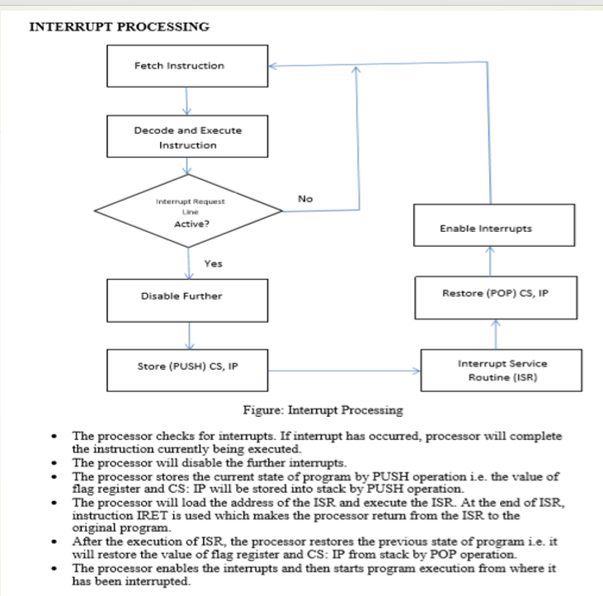

Sources of Interrupts and its classifications
The source of the Interrupt Service Routine (ISR) instructions for the 8085 and 8086 microprocessors depends on how the interrupt is triggered (hardware, software, or internal error) and whether it is vectored or non-vectored.
Classification of Interrupts
Vectored or non-vectored Interrupts (Knowing the address of the first instruction of ISR):
Vectored Interrupts: The address of the first instruction of the ISR is a fixed, predetermined memory location that the processor automatically jumps to. In other words, Processor knows the address of first instruction of the ISR.
Non-vectored Interrupts: The external hardware device requesting the interrupt must place the opcode for an instruction (typically a CALL or one of the RST instructions) on the data bus during the interrupt acknowledge (INA) cycle. The 8085 then executes this instruction, which provides the starting address of the ISR. In other words, processor doesn’t know the address of first instruction of the ISR. It is obtained by executing the opcode provided by the external peripheral device.
These sources of interrupt can be properly presented with the following table.
8085 Microprocessor | 8086 Microprocessor
Hardware Interrupt Pin:  INTR, RST 5.5, RST 6.5, RST 7.5 and TRAP (Non Maskable Interrupt)  Vectored Interrupts:  RST 5.5, RST 6.5, RST 7.5 and TRAP.  Processor knows the address of first instruction of these interrupts and jump there when one of the pins gets active high signal.  Non-vectored Interrupts:  INTR  Processor doesn’t know ISR, instead get the address of the first instruction of ISR from the opcode sent by the external device requesting interrupt.  Software Interrupt:  Software interrupts (RST 0 through RST 7)  Initiated by executing specific program instructions inserted by the programmer within the code itself. These instructions are single-byte opcodes that cause the processor to perform a subroutine call to a fixed vector address (e.g., RST 1 goes to 0008H).  Internal Interrupt (Error Condition)  The 8085 primarily uses its TRAP interrupt for critical internal/external error conditions like power failure. The source of the instruction is a fixed vector address (0024H) in memory, where the ISR for handling the error is located. | Hardware Interrupt Pin  INTR and NMI (Non Maskable Interrupt)  Vectored Interrupts:  Both NMI and INTR are vectored interrupts.  NMI: This is type 2 interrupt. The processor automatically uses the pointer located at a fixed location in the interrupt vector table (0008H) to find the ISR address.  INTR (Interrupt Request):  The external device (usually via an 8259A Programmable Interrupt Controller) provides an 8-bit interrupt type number to the processor during the interrupt acknowledge cycle. The 8086 uses this number as an index into the IVT to fetch the 4-byte (CS:IP) address of the corresponding ISR.  Software Interrupt:  Software interrupts are invoked by the INT n instruction, where 'n' is the interrupt type number specified in the instruction itself. The processor uses this type number to look up the ISR address in the Interrupt Vector Table.  Internal Interrupt (Error Condition)  These interrupts are generated automatically by the processor in response to certain execution errors (exceptions). The instruction source is implicitly handled by the CPU using dedicated predefined type numbers (0 through 4), which point to specific entries in the Interrupt Vector Table:  Type 0: Divide-by-zero error.  Type 1: Single-step (debugging).  Type 3: Breakpoint (INT 3 instruction).  Type 4: Overflow error (INTO instruction).

Interrupts pins and priorities
Both the 8085 and 8086 microprocessors manage interrupts through dedicated physical pins, but they use different priority schemes and architectural mechanisms to handle multiple simultaneous requests.
8085 Microprocessor
The 8085 has five hardware interrupt pins. These are ranked in a fixed, hardwired priority order.
Priority | Interrupt Pin | Maskability | Vector Address
1 (Highest) | TRAP (RST 4.5) | Non-Maskable | 0024H
2 | RST 7.5 | Maskable | 003CH
3 | RST 6.5 | Maskable | 0034H
4 | RST 5.5 | Maskable | 002CH
5 (Lowest) | INTR | Maskable | Not Fixed
- TRAP is the only non-maskable interrupt and is used for critical events like power failure.
- INTR is the only non-vectored interrupt; the external device must provide the vector during an INTA (Interrupt Acknowledge) cycle.
- Prioritization Note: The HOLD signal (used for DMA) actually has a higher priority than even TRAP.
8086 Microprocessor
The 8086 has only two dedicated hardware interrupt pins, but it can handle up to 256 different interrupt types through an Interrupt Vector Table (IVT).
Priority | Interrupt Source | Category | Vector Type
1 (Highest) | Internal Exceptions | Software/Internal | Type 0 (Divide by 0), etc.
2 | NMI (Non-Maskable) | Hardware Pin | Type 2 (Fixed at 0008H)
3 | INTR (Maskable) | Hardware Pin | Type 0–255 (Variable)
4 (Lowest) | Single Step | Internal | Type 1
- NMI: Used for catastrophic failures. It is non-maskable and triggered by a positive edge.
- INTR: Maskable via the Interrupt Flag (IF). If multiple devices are connected to INTR, their priorities are typically managed externally by a Programmable Interrupt Controller (PIC) like the 8259A.
- General Rule: In 8086, software-initiated interrupts (like INT n) generally have higher priority than external hardware interrupts because they are checked first during instruction execution.

Interrupt Service Routine/ Procedure
SIMILAR as Interrupt Processing Sequence.
Interrupt Service Routine
- An interrupt service routine (ISR) is a software routine that hardware invokes in response
to an interrupt.
- ISRs examine an interrupt and determine how to handle it.
- ISRs handle the interrupt, and then return a logical interrupt value.
- Its central purpose is to process the interrupt and then return control to the main program.
- An ISR must perform very fast to avoid slowing down the operation of the device and the
- operation of all lower priority ISRs.

As in procedures, the last instruction in an ISR should be iret.
ISR is responsible for doing the following things:
1. Saving the processor context
Because the ISR and main program use the same processor registers, it is the
responsibility of the ISR to save the processor’s registers before beginning any
processing of the interrupt. The processor context consists of the instruction pointer,
registers, and any flags. Some processors perform this step automatically.
2. Acknowledging the interrupt
The ISR must clear the existing interrupt, which is done either in the peripheral that
generated the interrupt, in the interrupt controller, or both.
3. Restoring the processor context
After interrupt processing, in order to resume the main program, the values that were
saved prior to the ISR execution must be restored. Some processors perform this step
automatically.
Interrupt Vector Table:
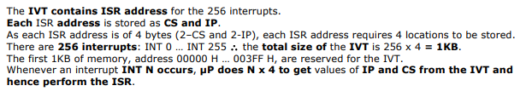
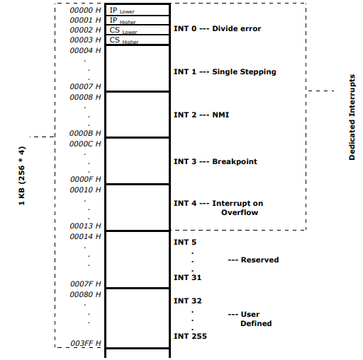

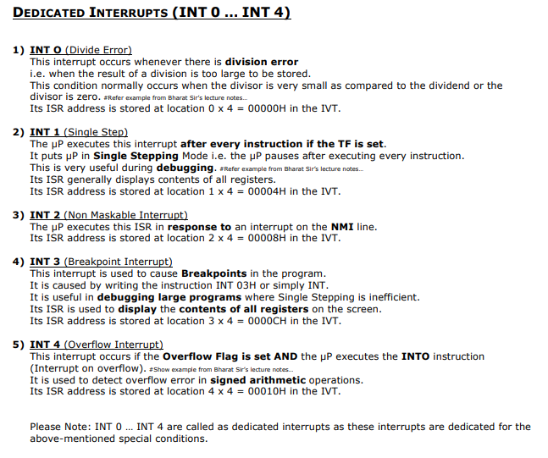

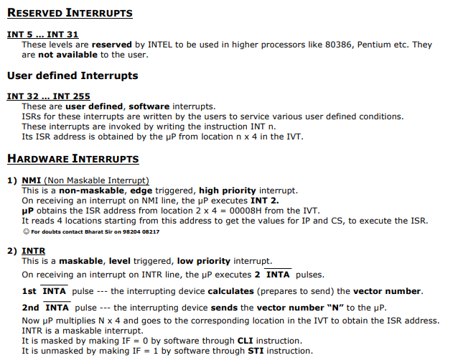

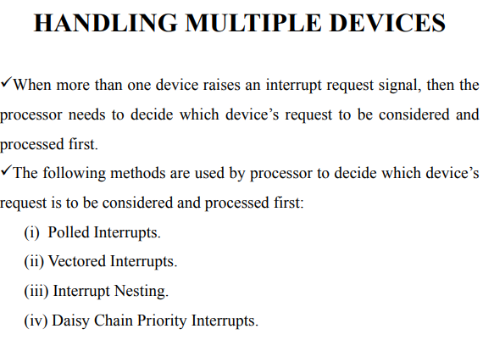
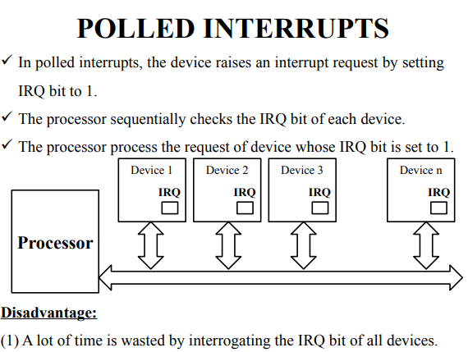

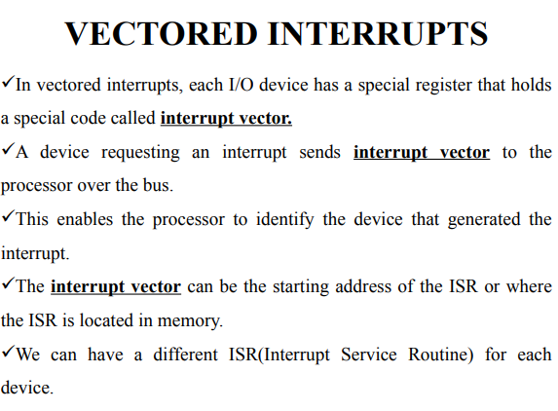

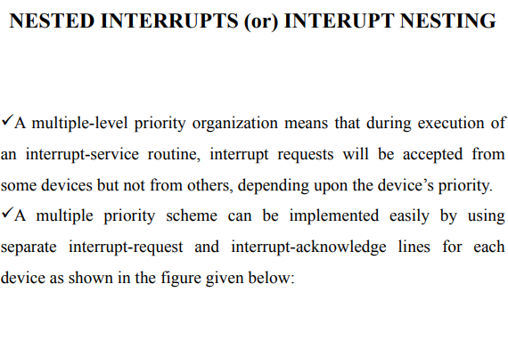

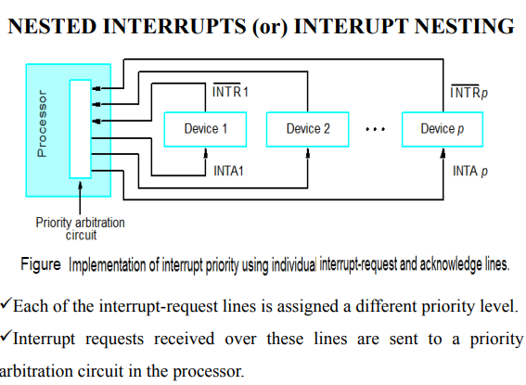

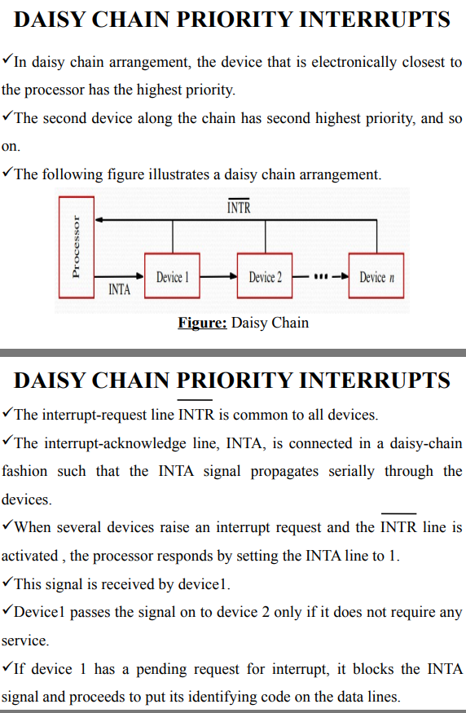

Programmable Interrupt Controller (PIC) Intel (8259) and its Architecture
Salient Features
1) PIC 8259 is a Programmable Interrupt Controller that can work with 8085, 8086 etc.
2) It is used to increase the number of interrupts.
3) A single 8259 provides 8 interrupts while a cascaded configuration of 1 master 8259 and 8 slave
8259s can provide up to 64 interrupts.
4) 8259 can handle edge as well as level triggered interrupts.
5) 8259 has a flexible priority structure.
6) In 8259 interrupts can be masked individually.
7) The Vector address of the interrupts is programmable.
8) 8259 has to be compulsorily initialized by giving commands, to decide several properties such
as Vector Numbers, Priority, Masking, Triggering etc.
9) In a cascaded configuration, each 8259 has to be individually initialized, master as well as
each slave
